Gerald D. Jeffs, MBA, PMP
2315 Fargo Ct. Tracy, CA 95377 • 925-487-5982
jeffsgerry@gmail.com • www.linkedin.com/in/gerryjeffs
Healthcare Research for the Area of Greater Tracy, California
The term “Quality Healthcare” is subjective and dependent on professional and personal experiences within a healthcare area, system, or network. This research attempts to bring together quantitative and qualitative information while removing bias from the author or other input providers. The author has never worked in the healthcare industry, but has extensive personal experience with multiple providers, in different cities, states, and countries. Do not take this research as an absolute, take it for the information it provides, do your own level of research, and make the best decisions for you, your family, and your community.
The only purpose of this research is to start a real conversation around the quality of healthcare in the area including and around Tracy, California. This conversation needs to be between city, county, and state leaders, health care providers, and the populations they all serve. Eventually these conversations may lead to a healthcare solution a population of 130,000 to 250,000 residents deserve.
Note: This research should be considered a “living document” continuing to be updated as new information becomes available.
Table of Contents
Why Research Healthcare in the Area of Greater Tracy 3
How it Started 3
The Result 4
The Objective 4
Network of Healthcare Providers 4
Focus Area Providers (1-15 Miles) 4
Healthcare Providers Outside the Focus Area (20-60 miles) 7
Populations 9
Focus Area (Greater Tracy) Population Estimates 9
Populations of Surrounding Healthcare Providers 10
Population Overlaps 12
Healthcare Rating Systems 12
Four Top Rating Systems 13
Social Media Ratings 14
Hospital Ratings 14
Service Capabilities Supported by Healthcare Systems 15
Care Level Capabilities 15
Service Capabilities 15
Patient Connection Capabilities 16
Emergency Departments 16
Emergency Department Wait Times 17
Hospital Staffing 17
Nursing 17
Medical Coverage 18
Federal & State Provided Coverage 18
Non-Federal or State Provided Coverage 18
The Conversations and the Ask 19
The Leaders 19
The Perceptions & The Questions 20
The Conversations 21
The Ask 22
Community Communications 22
Author/Primary Researcher Bio 23
Works Cited 24

Why Research Healthcare in the Area of Greater Tracy

How it Started
Early 2025 Gerald experienced a lower intestinal inflammation producing blockage and severe cramping pain. This experience was not new for him; he’s been experiencing this inflammation for over two decades and watched his mother manage the same issues for over four. Crohn’s Disease is an immune compromising disease and is hereditary. When the inflammation causes a full or partial blockage the level of pain is high, on a 1-10 scale normally above a 7. The treatment to reduce inflammation tends to be intravenous fluids, anti-nausea medications, and pain management.
In the past twenty-years Gerald has used healthcare providers in the Tri-Valley area, with San Ramon Medical Center and more recently Stanford Healthcare Tri-Vally being his primary places for care. With his corporate position with a global supply chain management organization, he has managed this in many U.S. cities and states, along with countries in Europe and Asia. Gerald and his wife moved to Tracy, CA at the end of 2019, but continued to use the established healthcare providers in the Tri-Valley. They did their research and struggled to find the same level of care as physicians in Tracy, with three test case experiences leading them to stay with a John Muir primary care physician in Pleasanton. Gerald’s intestinal issues would send him to an emergency department every 18-24 months, so there had only been one time he needed to go since moving, and he went to San Ramon.

The Story
Gerald arrived at Sutter Health Tracy Community Hospital approximately 1:50pm on Tuesday, March 25, 2005, with a severe Crohn’s flare up. He couldn’t maintain standing, so the security person helped him into a wheelchair. He was seen quickly by the registration person, and then the triage team. They were all made aware that his pain level was at an 8, and he told the Triage team he’s had two chest tubes, and one through his back without any pain meds, so he knows 10. They put him back in the waiting area and within a few minutes he was brought back for a blood draw and immediately returned to the waiting area. After an hour sitting in the wheelchair, He knew he needed to lay down, with a flareup, sitting is the worst possible position and he needed to be prone. The waiting room had a bench chair that would fit two, and a one-person seat next to it, with an arm rest between them. He made that his bed for the next four hours.
About an hour into laying down he spotted a nurse working with the pediatric patients, and pleaded for help, her response was “one minute please” and that was the last conversation they had. Another hour went by, and he saw a security person, he pleaded with him to get help, and he took Gerald’s tag number, talked to someone and came back to tell him they’ve had many ambulances. Gerald’s response was he didn’t need a bed, he needed intravenous fluids, anti-nausea medications, and something for the pain, they can do that while he sits in a chair. That was the last time he saw the security person.
Another hour goes by, and he sees a woman, he’s assuming a nurse, and asks if he’ll ever be seen, and she responds with “they plan on seeing everyone.” He told her he’s been there four hours, and his pain level is still an 8, and she tells him they only have fourteen beds, and they’ll get to him as soon as possible. He also made her aware that the entire time he’d been there not a single person had checked on him, she left with no form of care, compassion, and the trust Gerald had in the care he would receive once going back was nonexistent, no integrity.

A short time after that he called his neighbors to pick him up and bring him home. At home he self-medicated himself with a crushed Vicodin, a melatonin tablet, and a shot of Nyquil. That put him to sleep for 9.5 hours and allowed his flareup to slightly reside. He then drove to Stanford in Pleasanton where he was admitted through the emergency department, he received the intravenous fluids, anti-nausea medication, and started on pain management. He spent three nights at Stanford getting things under control before his discharge. He has changed his Gastroenterologist to one who works out of Stanford and has a plan for better disease management. Doing this in Tracy would never be an option under the current quality expectations, and there would be no level of trust.

The Result
The morning after Gerald’s attempt at receiving care at Sutter Community Hospital and before he left for the Stanford Hospital in Pleasanton, he documented the experience. With the event fresh in his mind, he needed to write down everything he could remember, and with that he mailed letters to Warner L. Thomas, President and Chief Executive Officer of Sutter Health, and copied his senior leadership team, including.
- Jennifer Bollinger, Senior Vice President and Chief Consumer & Brand Officer
- Ginger Chappell, Vice President and Chief Ethics & Compliance Officer
- William Isenberg, M.D., Ph.D., Vice President and Chief Medical & Quality Officer
- Conrad M. Vial, M.D., Senior Vice President and President, Sutter Health Network
- Caren Weakley, Senior Vice President and General Counsel
He then drove to Sanford where he spent the next three nights being cared for. The following Tuesday, April 01, 2025, Gerald spoke to the Tracy Mayor and City Council Members during the “Public Comments” time, where the council is not permitted to ask questions. The message was clear, Gerald found the level of compassion and care in Tracy is not providing a level of care the community deserved, and that he will start the conversation through qualitative and quantitative research.
This is how it all started.

The Objective
From the start the objective has been to create a sustainable and deepening conversation that leads to compassionate and trustworthy healthcare in the community. Making a large-scale change requires decision makers at the highest level of City, County, and State and partnering with executive leadership of providers of healthcare services.
This research is to assist in telling the story of healthcare in the area, to provide these decision makers with enough information to get a conversation started, and real subject matter experts take it over. Gerald is good at what he does, but healthcare systems and services are not where his expertise lies, and playing in the political arena is not something he desires.

Network of Healthcare Providers
In the greater area surrounding Tracy there is Mountain House, Lathrop, western parts of Manteca, Banta, Lytoh, Carbona, and we may expect further southern residents of Paterson to use the healthcare system. For this portion of the research, we looked at providers two to sixty miles from the Tracy Civic Center Plaza, and those with emergency departments.

Focus Area Providers (1-15 Miles)
There are four healthcare facilities with emergency departments within a fifteen-mile drive from the Tracy Civic Center Plaza.

Sutter Healthcare:
Sutter Healthcare has twenty-one of facilities covering the San Francisco Bay Area, Sacramento, the Central Valley, and Stanislaus County that provide emergency services. Located in Tracy is the Sutter Tracy Community Hospital, less than two miles from the Civic Center Plaza. Thirty miles out they have facilities in Modesto and Antioch, and one further south (60 miles) in Las Banos.

Sutter Tracy Community Hospital
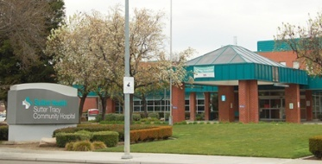
The Sutter Tracy Community Hospital, originally named Tracy Community Memorial Hospital, was mostly initially financed by community donations, was opened with a capacity of 49 beds on Dec. 12, 1948 (Matthews, 2024). The facility currently reports 77 Acute Beds, 8 ICU Beds, and may have as many as 14 Emergency Department beds. Sutter Health’s Website states “Sutter Tracy Community Hospital is the area's only full-service, acute care hospital, serving more than 100,000 people in the Tri-Central Valley region.” (About This Location, n.d.).

Sutter Halthcare Leadership / Primary Decision Makers
  Warner L. Thomas  President & Chief Executive Officer |   Cynthia Lee  Sr. VP and Chief Strategy & Growth Development Officer | 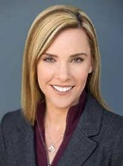  Grace Davis  Sr. VP and Chief External Affairs Officer

Mission, Vision, and Values
Mission: We prioritize our patients' care above all, while consistently supporting and valuing our people.
Vision: To be the most comprehensive, integrated health system for achieving and maintaining wellness.
Values: Excellence, Curiosity, Compassion, Inclusion, Teamwork, and Integrity.

Kaiser Permante: Manteca Medical Center
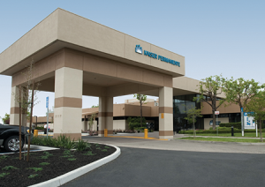
Kaiser Permanente is an American integrated managed care consortium headquartered in Oakland, California. Founded in 1945. The organization was initially established to provide medical services at Kaiser's shipyards, steel mills and other facilities, before being opened to the general public. Kaiser Permanente operates as a consortium comprising three distinct but interdependent entities: the Kaiser Foundation Health Plan (KFHP) and its regional subsidiaries, As of 2024, Kaiser Permanente serves eight states (California, Colorado, Georgia, Hawaii, Maryland, Oregon, Virginia, and Washington) as well as the District of Columbia and is the largest managed care organization in the United States. Permanente Medical Groups are physician-owned organizations, which provide and arrange for medical care for Kaiser Foundation Health Plan members in each respective region. The medical groups are for-profit partnerships or professional corporations and receive nearly all of their funding from Kaiser Foundation Health Plans. (Kaiser Permanente, 2025)
Because of the organization and customer structure the ability to research into Kaiser is limited. Because of the membership into the Kaiser Health systems there will be less emphasis on them as a future partner in elevating healthcare in the focused area.

Dignity Health
Dignity Health, a member of CommonSpirit, services California, Arizona, and Nevada with the closest offering emergency services being San Joaquin General Hospital in French Camp (15 miles from Tracy Civic Center), and St. Josephs Medical Center in Stockton (21 miles).
San Joaquin County is the Owner of San Joaquin General Hospital; Dignity Health is operating under a services agreement that expires in June 2025. The County Board of Supervisors for San Joaquin are the hospital related decision makers.

San Joaquin General Hospital

Dignity Health has a management role at San Joaquin General Hospital (SJGH). They are operating under a Management Services Agreement (MSA) with San Joaquin County. This agreement initially started in 2022 and was recently extended through June 2025 (Crowley, 2023).
San Joaquin General Hospital, established in 1857, is a 196-bed public teaching hospital located in French Camp, California. As the sole hospital in French Camp, it serves as a major healthcare provider for San Joaquin County. Affiliated with the University of California, Davis and the University of the Pacific, it offers a range of services including general medical/surgical care, high-risk obstetrics and neonatal intensive care, pediatrics and intensive care. Additionally, it functions as a Level II Trauma Center and provides teaching opportunities for medical students and residents from the affiliated universities. (San Joaquin General Hospital in French Camp, California, 2025).

Dignity Health Leadership / Partner Decision Makers
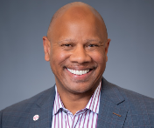  Wright Lassiter III, MHA  Chief Executive Officer |   Sheri Shapiro, MBA  Sr. Ex.VP and Chief Strategy Officer |   Terika Richardson, MPH  Sr. Ex. VP and Chief Operations Officer

Dignity Health Mission, Vision, and Values
Mission: As CommonSpirit Health, we make the healing presence of God known in our world by improving the health of the people we serve, especially those who are vulnerable, while we advance social justice for all.
Vision: A healthier future for all, inspired by faith, driven by innovation and powered by our humanity.
Values: Compassion, Inclusion, Integrity, Excellence, and Collaboration.

Central Valley Doctors Health System: Doctors Hospital of Manteca
The Central Valley Doctors Health System is an integrated healthcare system across the Central Valley consisting of three acute care hospitals – Doctors Medical Center in Modesto, Emanuel Medical Center in Turlock, and Doctors Hospital of Manteca.

Doctors Hospital of Manteca

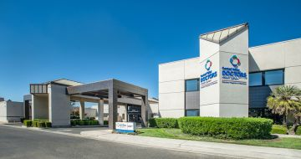
Doctors Hospital of Manteca was born in 1962, after local physicians realized their patients were leaving the community in search of their healthcare needs. When it opened its doors, the hospital had just seven doctors and 41 employees. Today, Doctors Hospital of Manteca is the largest private employer in the community with nearly 500 employees and a staff of more than 180 physicians. (Our History, 2025)
The facility is 15-miles from the Tracy Civic Center Plaza. Currently there is no information on the number of acute, ICU, or Emergency Department Beds. Leadership appears to be independent for each facility, with no higher-level decision makers.

Central Valley Doctors Health System -Manteca, Leadership / Input to Decision Making

  Jay Krishnaswamy  Chief Executive Officer | 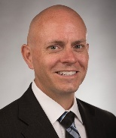  Jonathan Felton  Chief Operating Officer

Mission: There is no clearly stated Mission.
Vision: There is no clearly stated Vision.
Values: There are no clearly stated Values.

Healthcare Providers Outside the Focus Area (20-60 miles)
These are providers in addition to providers serving the focus area that also have facilities in this range but are not repeated.

Adventist Health
Adventist Health is a Seventh-day Adventist nonprofit organization headquartered in Roseville, California. They operate many hospital facilities throughout California, Oregon, and Hawaii. The closest facility to the area of Greater Tracy is Dameron Hospital in Stockton, twenty miles away.

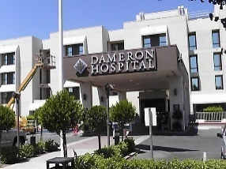
Dameron Hospital, Stockton CA
Dr. John Dameron founded Dameron Hospital in Stockton in 1912 with facilities for 20 patients. Ill health prompted him to sell the organization to a group of local doctors, staff, and businessmen in 1925, and expansion in 1927 brought bed capacity up to 55. They currently report 65 Acute and 24 ICU beds, emergency department beds are not reported.
The hospital was incorporated as Dameron Hospital Association in 1943, becoming an independent, not-for-profit medical facility governed by a seven-person board of directors and a 20-member board of membership. (History, 2025)

Adventist Health Leadership / Primary Decision Makers
  Kerry Heinrich Chief Executive Officer |   Todd Hofheins Chief Operations Officer
Mission: Living God’s love by inspiring health, wholeness and hope.
Vision: Compelled by our mission to live God’s love by inspiring health, wholeness and hope, we will transform the health experience of our communities by improving physical, mental and spiritual health; enhancing interactions; and making care more accessible and affordable.
Values: Be Love, Be a Force for Good, Be a Mission Owner, Be Welcoming, Be Curious, Be Brillant.

Stanford Medicine Health Care
Stanford Health Care, along with Stanford Health Care Tri-Valley and Stanford Medicine Partners, is part of the adult health care delivery system of Stanford Medicine. Combining clinical care, research, and education to advance the understanding and practice of medicine, we provide compassionate, coordinated care personalized for the unique needs of every patient. (About Us, 2025).
Stanford Health Care Tri-Valley is twenty to twenty-eight miles from Tracy, with a drive over the Altamont Pass.

Stanford Health Care Tri-Valley (Valley Care)
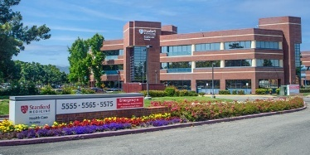
Back in the 1950s, the 18-bed St. Paul Hospital proved too small for the Livermore and Pleasanton communities. Weary of traveling to Oakland or Hayward for health care, residents banded together to build Valley Memorial Hospital on land donated by Kaiser Paving Company in Livermore.
Stanford Health Care – ValleyCare was formed in 2015 when ValleyCare Health System became part of Stanford Health Care. For 60 years, the health system has remained non-profit and has grown along with the Tri-Valley, expanding and adding services as the needs of the people grew. (About Us: History, 2025)
The facility reports 173 Acute and 23 ICU beds. The number of emergency department (ED) beds is not reported, but it is more than 15. The ED will also use overflow space on the second floor and have implemented a mid-level service where the patient will begin treatment in a chair area until a bed becomes available. This allows for initial physician review, intravenous fluids, the administration of other medicines, and patients can get a start on imaging needs when appropriate.

Stanford Medicine Health Care Leadership / Primary Decision Makers
  David Entwistle President & Chief Executive Officer | 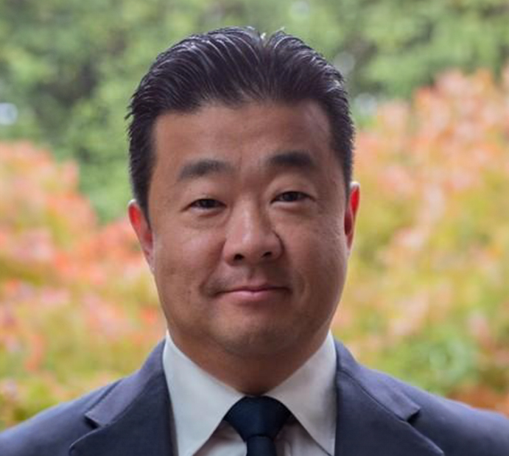  Tip Kim  Ex. VP and Chief Market Develop Officer |   Priya Singh  Ex. VP & Chief Strategy Officer
Mission: Preservation and improvement of the quality of care are the primary purposes of our medical staff organization.
Vision: Human-centered and discovery-led, we care deeply about every one of our patients.
Values: Quality and Safety

John Muir Health
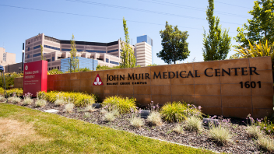
John Muir Health has three hospitals 35 to 50 miles from Tracy: San Ramon (35 miles), Walnut Creek (45 miles), and Concord (50 Miles). With the Walnut Creek Medical Center being the largest and is a regional trauma center.
John Muir Health includes two of the largest medical centers in Contra Costa County: John Muir Health Walnut Creek Medical Center, a 554-licensed bed medical center that serves as Contra Costa County's only designated trauma center; and John Muir Health Concord Medical Center, a 244-licensed bed medical center in Concord. Together, they are recognized as preeminent centers for neurosciences, orthopedics, cancer care, cardiovascular care and high-risk obstetrics.

John Muir Health also offers complete inpatient and outpatient behavioral health programs and services at our Behavioral Health Center, a fully accredited, 73-bed psychiatric hospital located in Concord.
Other areas of specialty include general surgery, robotic surgery, weight-loss surgery, rehabilitation and critical care. All hospitals are accredited by The Joint Commission, a national surveyor of quality patient care. In addition, John Muir Health provides a number of primary care and outpatient services throughout the community and urgent care centers in Brentwood, Concord, San Ramon and Walnut Creek. (John Muir Health: About Us, 2025)

John Muir Health Leadership / Primary Decision Makers
  Michael S. Thomas  President & Chief Executive Officer |   Paul Deeringer  Chief Strategy Officer

Mission: We are dedicated to improving the health of the communities we serve with quality and compassion.
Vision: We will exceed our patients’ expectations for seamless, consistently positive experiences with all aspects of John Muir Health, and we will distinguish ourselves.
Values: Excellence, High Reliability, Honesty, Integrity, Mutual Respect, Listening, Caring and Compassion, Patient Safety, Continuous Improvement, Stewardship of Resources, Access to Care.

Populations
For estimating populations we’ve used the website “Population Around a Point” (Forth, 2025). The site allows a user to place a point on a global map and define the radius of the circle in kilometers. It then provides an estimated population within the circle for 2025. The creator provides all the code used in making the calculations, so for this research we are considering the data credible. Based on local knowledge and information returned, the data appears to be correct.
For the estimated populations in this research, we have converted the radius from kilometers to miles, but since only one can be at a whole number value, we use kilometers to match the website and round off the miles, so the returned population is close but not perfect.
Because the population is calculated based on a circle and not specific to a city, there can be overlaps into areas not a part of the focus area.

Focus Area (Greater Tracy) Population Estimates
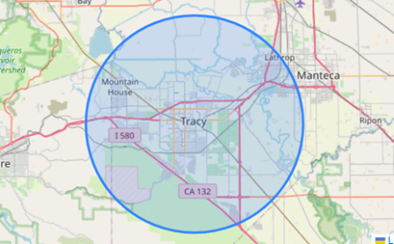
If the primary focus area is in the defined circle (10 miles or 16 kilometers) including Tracy, Mountain House, Lathrop, and capturing some populations around them, our source returns a value of ≈142,000. If there is an assumed population growth over the next fifteen years of 15%-25% for this area the population will grow to 163k-177k.

Populations of Surrounding Healthcare Providers
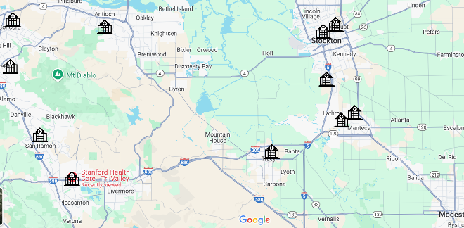
For a comparison of populations, healthcare providers may support we are using a five-mile radius (8 kilometers) from the provider’s facility. When looking at facilities North, East, and Northeast of the focus area, there is significant overlap in populations served. When we look at the facilities 20-50 miles west of the focus area, there is also population overlap.

Sutter Tracy Community Hospital
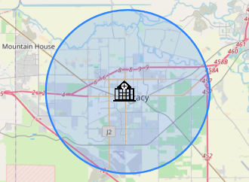
Within a five-mile radius of Sutter Tracy Community Hospital there is a population of ≈105,000. With a reported 77 acute beds this is ≈ 1 bed per 1,400 residents within five miles.

San Joaquin General Hospital – French Camp
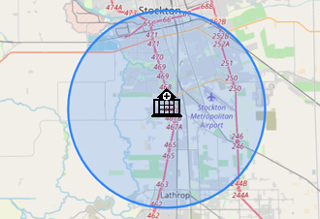
Within a five-mile radius of San Joaquin General Hospital there is a population of ≈131,000. With a reported 180 acute beds this is ≈ 1 bed per 750 residents within five miles.

Doctors Hospital of Manteca
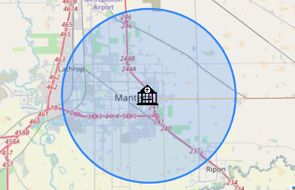
Within a five-mile radius of Doctors Hospital of Manteca there is a population of ≈92,000. There is no reporting on the number of acute or ICU beds.

Dameron Hospital – Stockton
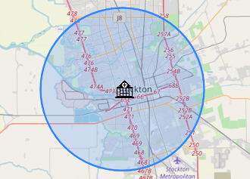
Within a five-mile radius of Dameron Hospital there is a population of ≈336,000. With a reported 65 acute beds this is ≈ 1 bed per 5,000 residents within five miles. There is a significant healthcare overlap in areas of this facility.

Saint Joseph’s Medical Center – Stockton
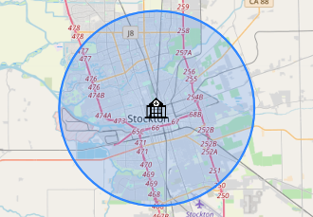
Within a five-mile radius of Saint Joseph’s Medical Center there is a population of ≈340,000. There is no reporting on the number of acute or ICU beds.

Stanford Health Care tri-Valley – Pleasanton
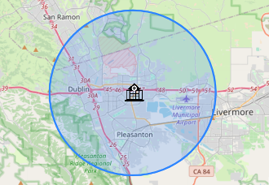
Within a five-mile radius of Stanford Health Care Tri-Valley there is a population of ≈173,000. With a reported 167 acute beds this is ≈ 1 bed per 1,000 residents within five miles.

San Ramon Regional Medical Center
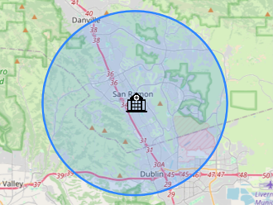
Within a five-mile radius of San Ramon Regional Medical Center there is a population of ≈168,000. There is no reporting on the number of acute or ICU beds.

Sutter Delta Medical Center
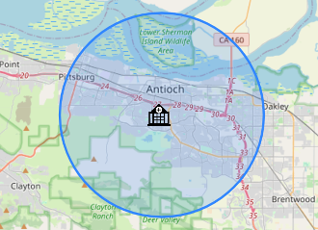
Within a five-mile radius of Sutter Delta Medical Center – Antioch there is a population of ≈165,000. With a reported 70 acute beds this is ≈ 1 bed per 2,300 residents within five miles.

Walnut Creek Medical Center
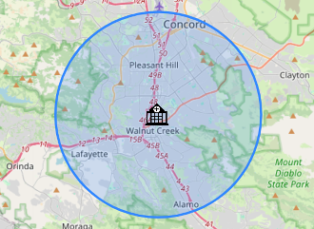
Within a five-mile radius of the Walnut Creek Medical Center there is a population of ≈250,000. With a reported 423 acute beds this is ≈ 1 bed per 600 residents within five miles.

Concord Medical Center
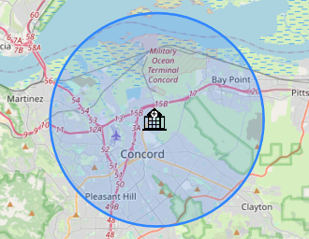
Within a five-mile radius of the Concord Medical Center there is a population of ≈225,000. With a reported 225 acute beds this is ≈ 1 bed per 900 residents within five miles.

Population Overlaps

Northeast Facility Overlaps
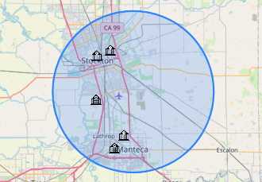
The five Northeast of Tracy with a population radius of ten miles covering Stockton, Lathrop, Manteca, and smaller eastern areas have a population of ≈440,000.

West & Northwest Facility Overlap
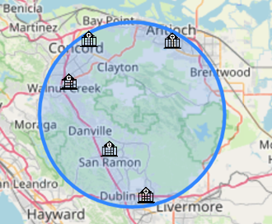
The facilities East and Northeast of Tracy are more spread out compared to the Northeast of Tracy, therefore a twelve-mile radius was used. The population estimate would be significantly higher if the radius covered the high population areas north and west of these facilities. The population within the twelve-mile circle is ≈688,000.

Underserved Area: Mountain House Region
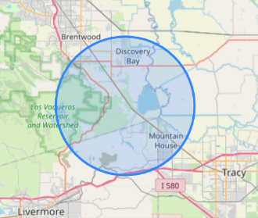
The seven-mile area around Mountain House up to Discovery Bay has a population of ≈30,000 that has no medical facility with an emergency room. Those residents either drive to Sutter Tracy Community Hospital, Antioch, Pleasanton, or some other location.

Healthcare Rating Systems
There are a few trusted rating systems, and they have some similarities in the data points, but not a lot of real information that allows the public to make healthcare decisions. People requiring healthcare services, particularly emergency services, will primarily be taken to the closest provider. Although all providers will accept anyone into their facility, they do not participate in all insurance networks, so a patient’s cost exposure can range from full to no coverage. So, although the information is interesting, healthcare rating systems don’t add significant value to this research.
In addition to formal rating systems there is social media that allows the public to express their pleasure or displeasure with services provided. With these there doesn’t seem to be a lot of middle ground in opinions, people either love the care provided or hate their experience. In many comments it’s clear the worst comments are from patients entering the system through emergency departments and positive comments come from schedule or planned procedures.
In this research we looked at four sites with differing rating systems, but three of the sites: Center for Medicare & Medicaid Services, Medicare, and Hospital Care Data are all interlinked and all using a five-star rating system. What’s interesting is the ratings from these systems are not all the same when searching on a specific hospital.

Four Top Rating Systems

Center for Medicare & Medicaid Services
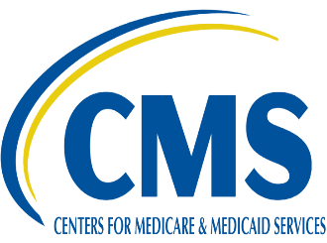
CMS is the federal agency that provides health coverage to more than 160 million through Medicare, Medicaid, the Children's Health Insurance Program, and the Health Insurance Marketplace. CMS works in partnership with the entire health care community to improve quality, equity and outcomes in the health care system. The Quality Rating System (QRS) is a quality reporting program that compares the performance of Qualified Health Plans (QHP) offered on Exchanges and accounts for both the quality of provided healthcare services and the health plan administration. CMS uses a Five-Star rating system to evaluate quality (5 is the highest). (CMS About Us, 2025)
Five-Quality Levels
- Mortality
- Safety
- Readmission
- Patient Experience
- Timely & Effective Care


Cal Hospital Care
Cal Hospital Compare features quality and performance information on California hospitals to help healthcare consumers make smarter and more informed choices when making medical decisions. Cal Hospital Compare is a performance reporting initiative managed by a multi-stakeholder Board of Directors, with representatives from hospitals, purchasers, health plans, and consumer groups. Cal Hospital Compare rates hospitals in California on clinical quality, patient experience, and patient safety. (Cal Hospital Compare, 2025)
Cal Hospital Compare’s Five-Rating Levels
Superior: Hospital performed well above average.
Above Average: Hospital performed better than average.
Average: Hospital Performed within the average.
Below Average: Hospital performed worse than average.
Poor: Hospital performed well below average.

Medicare
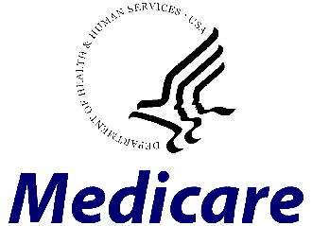
Medicare is health insurance for people 65 or older. More than 66 million people in the U.S. get their health coverage from Medicare. A federal government website managed and paid for by the U.S. Centers for Medicare and Medicaid Services. Users can compare information about the quality of care at over 4,000 Medicare-certified hospitals, including over 130 Veterans Administration (VA) medical centers and over 50 military hospitals, across the country. They have combined original provider compare sites, giving one place to start finding any type of care needed. (Medicare.gov, 2025). One rating system is CMS, so there is overall in these measurements.
Quality Measurements
- Heart Attacks
- Pneumonia
- Readmission
- Safety
- Care

Hospital Care Data

Hospital Compare is a program developed by the Centers for Medicare and Medicaid Services (CMS). Hospital Compare enables representative organizations of consumers, doctors, hospitals, employers and such like, to collaborate. In addition, Hospital Compare offers you the opportunity to find over 4000 Medicare certified hospitals across the country, and to compare the quality of care that they each provide. Using data points from different aspects of a patient’s experience, they use a 1-5 Star rating (Hospital Care Data, 2025)
This is the least helpful of the sites, and a user would expect many popup advertisements.

Social Media Ratings
Users in search of information on the quality of healthcare need to consider the input into social media ratings. When reviewing these rating platforms for specific locations it is common to see negative comments and low reviews for those entering a hospital through an emergency department, and the higher ratings for those entering through planned procedures.

Yelp

Yelp states on their site “Our community is built on trust. Whether you’re a consumer or a business owner, you put your trust in us to provide information people can rely on to make good decisions. We work hard to maintain that trust, and make Yelp truly helpful for everyone. Businesses earn great reviews on Yelp the same way they build their reputations in the community: by creating great products, services, and customer experiences. Yelp works hard to feature content that reflects real experiences that consumers are inspired to share”. (Yelp, 2025)

Google

When finding a business using Google Maps, a user has an opportunity to leave a review. The review ratings are 1-5, like Yelp. There does not appear to be oversight to the postings, but a business is able to respond.

Hospital Ratings
Below is a rating of hospitals by the various rating systems, with the last column being the average of all that are reported. This demonstrates that although CMS, Medicare, and Hospital Care Data are interlinked, they do not always provide the same outcome in a rating. All these ratings need to be taken with a degree of uncertainty and understanding that they do not tell the whole story. Therefore, the information is interesting but should not be used in a final decision on where to seek healthcare.
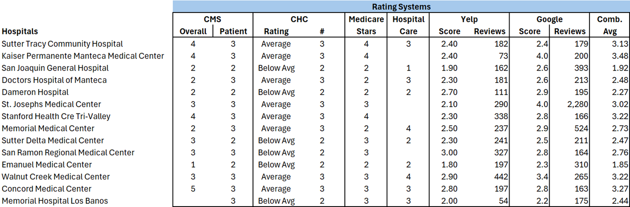

Service Capabilities Supported by Healthcare Systems
Not every healthcare provider will have all the capabilities or be able to serve every patient’s needs. Those needs are dictated by severity of illness or injury, complexity of need, and some needs will require a specialty not every facility has the capacity to handle. What is listed in this paper is just a list of what represents quality care and would be something to build on over time. We are not going into a detailed description of each capability; that would require subject matter expertise, which the author/researcher does not possess.

Care Level Capabilities
The two primary ways in which a patient enters a hospital are through emergency services or a planned procedure that may or may not require in patient care.
- Trauma & Intensive Care
- Emergency & Urgent Care
- Acute Care
- Planned & Preventative Care

Service Capabilities
Providing best in class services in all areas would be difficult at best for any health care provider, but most hospitals do provide that level of care in some of the areas, and patients needing a higher level of care in any specialty may require transfer to another provider. The challenge then becomes acceptance of insurance, all hospitals may take the patient, but not all patient insurance providers will be in the new providers accepted network, this can cause a financial burden that will never be covered by the patient.
- Behavioral & Mental Health
- Psychiatric Services
- Oncology Treatment
- Cardiovascular
- Gastroenterology
- Orthopedics
- Neurosciences
- Maternity & Pediatrics
- Chemical Dependency
- Primary Care Services
- Social & Geriatric Services
- Occupational Health & Safety Physical Rehabilitation
- Medical Imaging
- Lab Services

Patient Connection Capabilities
Most healthcare providers can communicate with patients through technology, but not all patients have the understanding or comfort in using fast-changing technologies. A patient may also be required to balance care with multiple insurance providers; consider a person using Medicare, Medicaid, supplemental programs, and other forms of insurance, they now need to become experienced in navigating all these providers, so they don’t go bankrupt when obtaining care.
- Insurance Acceptance
- Telehealth & In-Person Visits
- Nurse Advice & Health Education
- Health Platforms & Tech Support

Emergency Departments
When a person enters a hospital through an emergency department, they’re doing it for one of many reasons. Finding current sources is not possible on this topic, but Google does provide an AI generated response from multiple sources. Here is what Google AI has on the topic,
“People use an Emergency Department (ED) for a variety of reasons, primarily when they believe they are experiencing a medical emergency or require urgent medical care that cannot wait for a regular doctor's appointment”.
- Medical Emergencies: Life threatening, severe injuries, and serious infections or illnesses.
- Urgent Medical Conditions: Conditions requiring immediate, but not life-threatening attention, and when primary care is unavailable.
- Non-Urgent Conditions (Though Often Seen in the ED): Convenience and accessibility, perceived severity, and a need for specific services, such as medication refills or routine examinations that may not be available elsewhere.
Continuing with the search we asked the question regarding the number of insured versus uninsured that use an emergency department. Again, the only information is provided by Google AI. Here is that result.
“In 2023, about 8% of the population, or 26 million people, were uninsured. While some studies suggest that the uninsured are not major users of emergency departments (ERs), others indicate that uninsured individuals do visit the ER more frequently than insured individuals. However, insured individuals often account for a larger proportion of total ED visits”.
- Frequency of ED Visits: Some studies have found that the uninsured are more likely to visit the ER for non-urgent care than insured individuals.
- Impact on Healthcare Systems: The high cost of ER visits for the uninsured can lead to financial strain and can also contribute to increased costs for hospitals and healthcare systems.
- Access to Care: Uninsured individuals may face challenges in accessing primary care and may rely more heavily on ERs for routine and non-urgent care.
- Affordable Care Act (ACA): The ACA aimed to increase insurance coverage, which has led to a decrease in the percentage of ED visits by uninsured individuals, particularly among those aged 18 to 64.
Although the above is generated from an AI tool, what was returned makes logical sense.

Emergency Department Wait Times
A search for ER wait-times at hospitals within a fifty-mile radius of Tracy through the website HospitalStats.org (ER Wait Times, 2025) returned a wide two-hour range of results. With a minimum of 2:05, a max of 4:11, the average comes in at 3:05. It is unclear in reviewing the website how frequently these times are updated, or when the last update was made.
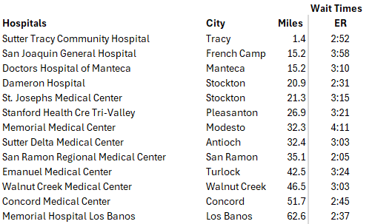

Hospital Staffing

Nursing
According to NurseJournal, California and Massachusetts have laws about nurse-to-patient ratios in hospitals. The California RN Staffing Ratio Law defines the number of patients nurses may oversee in each hospital unit. For example, a nurse in the post anesthesia care unit may care for two patients at a time. California law also states that patients’ severity of illness must be documented using an acuity tool. (Alexa Davidson, 2023)
The law required the state Department of Health Services (DHS) to establish specific ratios for specific hospital units. In 2002, DHS issued proposed regulations to implement the law, including these specific ratios. Final regulations were issued on July 1, 2003 incorporating extensive testimony presented during numerous public hearings as well as public comment (i.e., letters submitted). (John Kasprak, 2004)
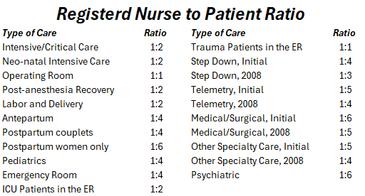

Medical Coverage

Federal & State Provided Coverage

Medicare
Medicare is a federal health insurance program in the United States for people age 65 or older and younger people with disabilities, including those with end stage renal disease and amyotrophic lateral sclerosis (ALS or Lou Gehrig's disease). It started in 1965 under the Social Security Administration and is now administered by the Centers for Medicare and Medicaid Services (CMS).
Medicare is divided into four parts: A, B, C and D. Part A covers hospital, skilled nursing, and hospice services. Part B covers outpatient services. Part D covers self-administered prescription drugs. Part C is an alternative that allows patients to choose private plans with different benefit structures that provide the same services as Parts A and B, usually with additional benefits. (Medicare.gov, 2025)

Medicare Supplement Insurance
Medigap (also called Medicare supplement insurance or Medicare supplemental insurance) refers to various private health insurance plans sold to supplement Medicare in the United States. Medigap insurance provides coverage for many of the co-pays and some of the co-insurance related to Medicare-covered hospital, skilled nursing facility, home health care, ambulance, durable medical equipment, and doctor charges. Medigap's name is derived from the notion that it exists to cover the difference or "gap" between the expenses reimbursed to providers by Medicare Parts A and B for services and the total amount allowed to be charged for those services by the United States Centers for Medicare and Medicaid Services (CMS). (Wikipedia, 2025)

Medicaid
Medicaid is a government program in the United States that provides health insurance for adults and children with limited income and resources. The program is partially funded and primarily managed by state governments, which also have wide latitude in determining eligibility and benefits, but the federal government sets baseline standards for state Medicaid programs and provides a significant portion of their funding. States are not required to participate in the program, although all have since 1982. (Wikipedia, 2025)

Non-Federal or State Provided Coverage
United Healthcare is one source of definitions for the different types of plans (United Healthcare, 2025).

HMO - Health Maintenance Organization
This is named for the overall goal of this kind of plan — which is to help maintain your health.
HMO plans typically require you to choose a primary provider, or primary care physician (PCP), in the HMO plan network. This provider will refer you to other network providers as needed. Premiums are often lower because of the defined network which can help control costs. These plans may also offer low or no deductible options. Providers or doctors either work for the HMO or contract for set rates. For most plans, you’re required to use health care facilities or doctors that are in the HMO network. Out-of-network care is typically allowed in emergency cases only. (United Healthcare, 2025)

PPO – Preferred Provider Organization
The name refers to its network of contracted PPO providers. With this type of plan, there are preferred providers who can offer care at the lowest out-of-pocket cost (compared to out-of-network providers).
PPO plans tend to give you more flexibility to choose the providers you prefer to visit for care. If you choose an out-of-network provider, you’ll likely pay more. Premiums tend to be higher and are commonly paired with a deductible. Networks include providers and facilities that have negotiated lower rates on the services they perform. PPO health plans have access to those negotiated rates. When you choose a provider in the network, you may have lower out-of-pocket costs than if you choose out-of-network providers. Out-of-network care is usually included in the benefit plan, but it may be at a reduced level of coverage and benefits. (United Healthcare, 2025)

EPO – Exclusive Provider Organization
This refers to the rule of this type of plan that requires members to get care within the plan’s network of select providers. If you get care outside the EPO network, you’ll likely have to pay the full cost of that visit.
EPO plans generally let you see any network provider you choose. There’s no requirement to choose a primary care physician or get referrals to see a specialist. These plans do not offer out-of-network benefits. Doctors and facilities that participate in an EPO are paid per service. They don’t directly work for or contract with the EPO carrier for a set rate. Instead, they have negotiated lower rates on services they perform for plan members. May restrict your coverage to care in the plan network. Out-of-network coverage may only be available for emergencies. (United Healthcare, 2025)

POS – Point of Service Plan
With this type of plan, each time you need health care (the time or “point” of service), you can decide to choose network care and allow your primary care physician to manage your care, or you can decide to go outside of the network and seek care from a doctor of your choosing.
POS plans usually require you to get referrals to see specialists. Most plans will have some coverage for out-of-network care — often with a higher copay. These plans are like a combination of an HMO and PPO plan. Network providers have negotiated rates on medical services for members with a POS health plan. Coverage is generally for care in the plan network for services. Out-of-network services may be authorized in limited cases. Benefits and coverage for out-of-network care may be less than if you stay in the plan network. (United Healthcare, 2025)

HDHP – High-Deductible Health Plan
It’s a type of health insurance plan that offers lower premiums in exchange for higher out-of-pocket costs. With HDHPs, you’ll pay less each month, but more when you get care compared to other health plans. (United Healthcare, 2025)

The Conversations and the Ask

The Leaders
Stakeholders cover a wide area from the resident’s seeking healthcare, to city, county, and state leaders, then the organizations providing healthcare services.

City Leaders
- Tracy Mayor & City Council
- Mountain House Mayor & City Council
- Lathrop Mayor & City Council

County & State Leaders
- County Supervisor, District 5: Robert Rickman (Mountain House, Tracy, Escalon, Ripon)
- County Supervisor, District 3: Sonny Dhaliwal (Lathrop, Manteca, Stockton)
- CA State Assemblymember, District 13: Rhodesia Ransom (Tracy, Mountain House, Stockton)
- CA State Senator, District 5: Jerry McNerny (Pleasanton, Livermore, Mountain House, Tracy, Lathrop, Manteca, Escalon, Ripon, Stockton, Lodi)

State & County Leadership District Overlap
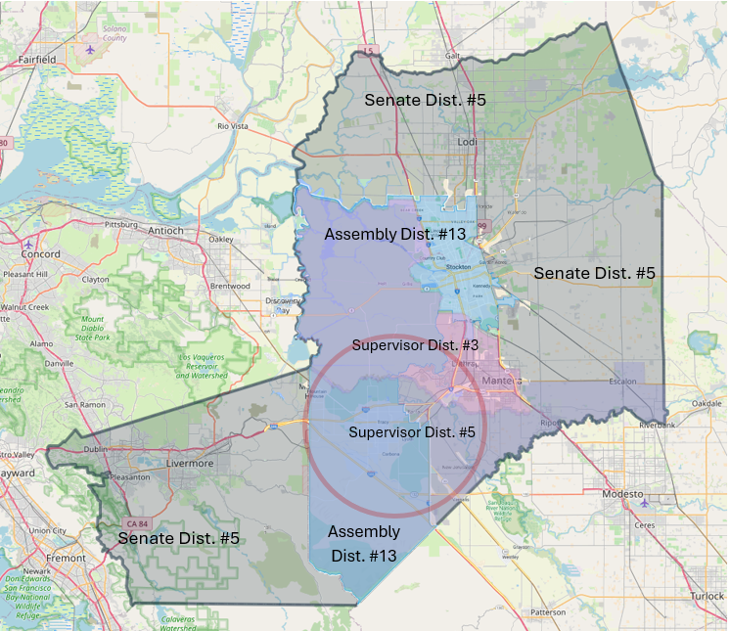
Senate District #5 and Assembly District #13 have leadership responsibility for the area in discussion. County Supervisors for Districts #3 and #5 share responsibility within the area.

The Perceptions & The Questions
Perceptions are those of the author and discussions with people closer to the healthcare system in Tracy. The questions represent what is needed for deeper research.

Current Generalized Perceptions
- Sutter Health is the provider discussed when the need for healthcare improvements is raised.
- Kaiser is looked at as a secondary provider in the area.
  - Kaiser is limited to the population they can serve because of their membership criteria.
- The current healthcare is known by the residents and city leaders, but no serious conversations are happening that drive improvements.
  - Sutter seeks patient input to quality, but the information is not available to the public.
- Residents that can go outside of Tracy do seek other providers for their healthcare.
  - This may be traveling north or west of Tracy.
  - Kaiser and the V.A. Hospital are also a considerable part of the area healthcare.
- The investment in a new medical center is not currently being discussed with any providers.
  - Sutter Health is adding small incremental operations, but nothing that improves the Emergency Department capabilities, or adding acute and ICU beds.
- Insurance networks increase the limitations of a patient’s choice on where to seek healthcare.
  - A Medicare patient with Aetna PPO does not have access to Sutter Tracy, the nearest hospital with an ED is San Joaquin General, Doctors Hospital of Manteca, and Stanford Tri-Valley, from there it goes to all others.
- Not all providers can deliver a full solution; there are perceptions of limitations.
  - Sutter Health may be the primary provider with the closest connection to the community and maintains a large network.
  - John Muir would be a welcome provider if willing to expand southeast of Mt. Diablo; they have the size and capabilities to meet the needs.
  - Stanford Healthcare has a well perceived reputation, and they may be considering expansion, but doubtfully they would go east. They would be a welcome partner if the distance to Palo Alto wasn’t so great. Another limitation may be if a built-to-suit facility is needed.
  - Dignity Health appears to be more of a management services organization, not building a new business model that delivers the growing need by investing in facilities.
  - Kaiser’s limitations would be in membership criteria, limiting access to many in the area.
  - Adventist Health does not appear to have organizational strength to be a high potential option.
  - Central Valley Doctors Health System may be the least feasible option, they maintain the management of three facilities, and all appear to be under local leadership.

Open Questions
- How many residents in the focus area go to other areas for their healthcare needs?
  - How many people go west to Stanford, San Ramon, John Muir, and Kaiser?
  - How many go to Manteca to Doctors Hospital or Kaiser?
  - How many go north to San Joaquin General, St. Joseph’s, or Dameron?
  - Where do others go?
- How many patients are transferred from Sutter Tracy Community Hospital to Sutter locations or other providers?
  - Transfers because of bed limitations?
  - Transfers because of type/severity of need?
  - Transfers for other reasons?
- Will emergency responders take a patient within the focus area to any other facility?
  - What happens if Sutter Tracy is not in a patient’s insurance network?

The Conversations

City Councils
City Mayors and City Council Members would have planned conversations or committee updates on healthcare in their area of responsibility. These conversations or updates may include a variety of topics, but are not limited to:
- Short- and long-term strategic plans of healthcare providers supporting the area.
- Public feedback on the current healthcare provided.
- What is the City’s position on additional healthcare needs.
- What are the City’s primary concerns with the current healthcare support.
- Coordination with other city councils, county supervisor, state assemblymember and state senator.
- Communications with healthcare provider leadership teams.

County Supervisor
The county supervisor can be the link between the different city councils, and the senior executives and decision makers for healthcare providers. The San Joaquin County Supervisors have oversight and decision-making authority for San Joaquin General Hospital. That operation is under a Management Service Agreement with Dignity Health that started in 2022 and has been extended to June 2025.
Conversations would be with city leaders, healthcare provider leadership, updates to constituents, and shared information with state leaders.

State Assemblymember
Assemblymembers have a close connection with constituents and their needs that feed into legislative efforts. The link between constituents and legislation may drive conversations with healthcare provider leadership, and city and county leaders. The Assemblymember would maintain updates with the city councils within the district, the county supervisor(s), and state senator(s) when appropriate. Updates to the public would be through normal communication plans and methods.

State Senator
With the size of a State Senator’s district, they can bring leaders into a conversation that crosses counties, assembly districts, cities, and healthcare providers. One area of a senator’s district may have healthcare options not considered in other communities, so opening new communication paths. The state senator would receive updates from leaders within their district, discuss legislation with state assemblymembers and other state senators, and continue conversations with healthcare executive teams.

Healthcare Executives
Open conversations are needed with executive teams of healthcare providers. Not all healthcare providers may be capable of delivering a solution that is needed for the future growth in the area discussed in the research, but there are a few. A recommendation may be starting with Sutter Health, John Muir, Dignity Health, and Stanford Healthcare.
Once communication channels are open, conversations can begin with city, county, and state leaders, discussing current and future needs, and how partnerships could be built.

The Public
An engaged public is key to improving the healthcare system in the area where they live. Getting the public engaged may be one of the most difficult challenges. Public comments tend to lean towards problems and a small percentage of a community’s residents speak up, so community representation may fall short. A committee reporting into a city council may bridge some of the gaps, but there would need to be additional considerations. It’s possible to push out surveys to a community, have sections of a city’s website dedicated to healthcare, appoint a city healthcare spokesperson, and a variety of other communication methods that allow two directional conversations.

The Ask
The “Ask” is simple. Raise the conversation around healthcare in areas you control, be consistent in conversations, be progressive in depth, be willing to cross into other communities, engage with others to build a solution for all, and be transparent.
It’s everyone’s responsibility to improve healthcare in the areas we live. To move forward we need an engaged public, city leaders willing to take on the biggest challenges, county and state leaders with the ability to bring decision makers together, and healthcare providers willing to talk.

Community Communications

YouTube Video Communications
These videos are progressive, each newer video builds on the research from the last. There will be corrections and added details to earlier portions of the research, so there may be revisiting past work videos.
The first video is Gerald announcing his intentions of researching healthcare during the “Public Comments” time at the Tracy City Council meeting April 01, 2025.
https://youtu.be/ZAjQYUAt25Y
The second video was on April 12, 2025, Gearld pushed out an update video through YouTube, Facebook, and LinkedIn. All his updated videos are sent to the Tracy Mayor and City Councilmembers.
https://youtu.be/wNGBoIWytiM
The third update video on April 18, 2005, begins with understanding populations in the focused area and looks at the surrounding 50-mile radius.
https://youtu.be/IejO2bvwFxk
The fourth update video on May 05, 2005, defines who in City, County, and State leadership positions we will provide an understanding of the objectives, the reason for this research, and how their teams may assist. It also touches on what a high-quality healthcare system in our area would look like.
https://youtu.be/upes9Mm2i1o
June 14, 2025, Update Video
https://youtu.be/9opfXYf47-U
June 25, 2025, Update Video
https://www.youtube.com/watch?v=7I1wLrIHaSw


Author/Primary Researcher Bio
Gerald is the sole proprietor of Clarity Execution, a legal entity started after leaving a twenty-five-year corporate career in global supply chain and logistics. His responsibilities included project portfolio ownership of international logistics projects, domestic warehousing startups, and the implementation of strategic initiatives. He has taught project management and strategy management throughout the Americas, Greater Asia, and Europe.
Clarity Execution is giving him the freedom to take a multipronged approach to his career. There are three main categories to his focus. One is providing mentorship and education in project and strategy management with professional organizations, providers of higher education, and career development with school district partnerships. Another is supporting local and regional nonprofit organizations in strategy development and implementation that allows them to deliver services to the communities they serve. And last as a strategy, portfolio, program or project manager for short to mid-term contracts.
He has an Executive MBA from St. Mary’s College of California, a Master’s Certification in Project Management from George Washington University, Advanced Project Management Certification from Stanford, is a Project Management Professional (PMP®), and is a certified Disciplined Agile Scrum Master (DASM).

Works Cited
(2025, May 22). Retrieved from Cal Hospital Compare: https://calhospitalcompare.org/
(2025, May 22). Retrieved from Medicare.gov: https://www.medicare.gov/care-compare
(2025, May 22). Retrieved from Hospital Care Data: https://hospitalcaredata.com/
(2025, May 22). Retrieved from Yelp: https://trust.yelp.com/
About This Location. (n.d.). Retrieved from Sutter Health: https://www.sutterhealth.org/find-location/facility/sutter-tracy-community-hospital-1043246708
About Us. (2025). Retrieved from Stanford Medicine Healthcare: https://stanfordhealthcare.org/about-us.html
About Us: History. (2025). Retrieved from Stanford Medicine Health Care Tri-Valley: https://stanfordhealthcare.org/tri-valley/about-us/history.html
Alexa Davidson, M. R. (2023, March 21). Nurse-to-Patient Staffing Ratio Laws and Regulations. Retrieved from NurseJournal: https://nursejournal.org/articles/nurse-to-patient-staffing-ratio-laws-by-state/
CMS About Us. (2025, May 20). Retrieved from Centers for Medicare & Medicaid Services: https://www.cms.gov/about-cms
Crowley, H. (2023, October 25). Press Release: San Joaquin General Hospital. Retrieved from San Joaquin County: https://www.sjgov.org/press-releases/press-release-detail/2023/10/25/san-joaquin-county-and-dignity-health-announce-18-month-management-services-agreement-extension-at-san-joaquin-general-hospital
ER Wait Times. (2025, June 8). Retrieved from Hospital Stats: https://hospitalstats.org/ER-Wait-Time/search?zip=95377&distance=50
Forth, t. (2025). Retrieved from Population Around a Point: https://www.tomforth.co.uk/circlepopulations/
History. (2025). Retrieved from Damerorn Hospital: https://www.dameronhospital.org/about-us/history/
John Kasprak, S. A. (2004, February 10). CALIFORNIA RN STAFFING RATIO LAW. Retrieved from OLR Research Report: https://www.cga.ct.gov/2004/rpt/2004-r-0212.htm
John Muir Health: About Us. (2025). Retrieved from John Muir Health: https://www.johnmuirhealth.com/about-john-muir-health.html
Kaiser Permanente. (2025). Retrieved from Wikipedia: https://en.wikipedia.org/wiki/Kaiser_Permanente
Matthews, S. (2024). Community celebrates 75th Anniversary of STCH opening. Tracy Press.
Our History. (2025). Retrieved from Central Valley Doctors Health System: https://www.doctorsmanteca.com/about/our-history
San Joaquin General Hospital. (2025, January 13). Retrieved from Wikipedia: https://en.wikipedia.org/wiki/San_Joaquin_General_Hospital
San Joaquin General Hospital in French Camp, California. (2025). Retrieved from County Office.org: https://www.countyoffice.org/san-joaquin-general-hospital-french-camp-ca-bf6/
United Healthcare. (2025, June 22). United Healthcare. Retrieved from United Healthcare - Understanding HMO, PPO, EPO, POS plans: https://www.uhc.com/understanding-health-insurance/types-of-health-insurance/understanding-hmo-ppo-epo-pos
Wikipedia. (2025, June 22). Retrieved from Wikipedia: Medicare: https://en.wikipedia.org/wiki/Medicare_(United_States)

